Indoor Cats Live Longer, Live Better
Your cat may tell you the great outdoors is lot of fun - grass to roll in, trees to climb. However, cats, like children, depend on us to recognize danger and protect them from harm.
In addition to grass and fresh air, the outdoors poses many risks to your pets. Lethal risks that can be completely avoided:
TRAFFIC: To listen to some people, a pet's "getting hit by a car" is just part of pet ownership. Your pet is not likely to agree....
POISON: Cat's don't usually resist the temptation of checking out neighbors' yards, the hoods of their cars, and their flowerbeds. Although it is illegal and inhumane, some people put out a poisonous substance to get rid of those pawprints on a car. Poison also may be put out for other animals, and pets are accidentally poisoned, such as by eating poisoned mice.
CRUELTY: Unfortunate, but true, there are more than enough people in this world who are intentionally cruel to animals.
INJURIES: If your pet goes outside, it risks injurious or deadly fights with other animals, and also exposure to those animal's diseases. Bite wounds often abscess, resulting in a serious injury for your pet, and a veterinary bill for you.
DISEASE: Even if your pet is vaccinated, it runs the risk of serious diseases: * Leukemia - The vaccine for feline leukemia, although valuable, provides about 80% - 85% protection, leaving your pet still at some risk of contacting leukemia, a deadly disease transmitted basically by saliva, from another cat. * FIV - Feline Immunodeficiency Virus - FIV is a disease that compromises the immune system of the cat. There is no vaccine for FIV, and there is no cure. FIV is generally transmitted between cats by biting. A blood test determines if the cat is FIV positive. Scientific evidence indicates FIV is not communicable to humans. A number of stray cats are FIV positive, and your cat runs a significant risk of FIV contact with these outdoor cats. For more information regarding FIV, contact your veterinarian.
No cat, no neighborhood, is immune from these dangers. Give your cat a long, safe, healthy life - indoors!
Make Life Inside Fun -- Toys, playtime with you, a window to look out of, scratching posts, and a catnip from time to time more than compensate for the risks your cat faces outdoors.

Declawing! What You Need To Know
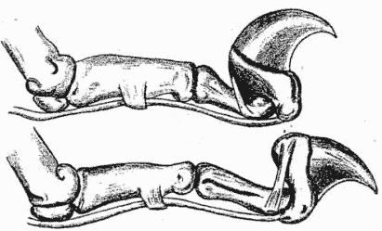
What does it mean when a cat is declawed? How is it done? Examine these drawings. The cat's claw is not a toenail at the end of the toe as in other animals. It is movable digit attached to muscle as a finger might be. Note the strong ligaments and tendons which give power to extend and retract the claws. This is unique in cats. Without this your cat would not be able to properly grasp, hold or establish footing for proper walking, running, springing, climbing or stretching. Think of the cat as having 10 toes on each foot. Declawing is akin to cutting off half their toes. When the end digit, including the claw is removed, the sensory and motor nerves are cut, damaged and destroyed. They do not repair themselves or grow back for many months. Following the surgery there is a wooden lack of feeling, then a tingling sensation during the long convalescence while the cat must walk on the stub end of the second digit. Remember that during all this time the cat may not "rest" his feet as we would after a similar operation but must continue to scratch in his litter box, walk and attempt to jump as usual regardless of his pain.
Since cats have keener senses than humans, they suffer even more than humans. Many pain killing drugs, including aspirin, do not agree with cats and can cause illness or even death. Anyone who has had surgery will appreciate the problem that can be created by the inability to take pain-relieving medication. It is also possible for the claws to grow back, but often not in the normal manner, instead they may grow through the top or bottom of the paw, creating a bloody, painful sore. An Atlanta news station recently had a story of a declawing followed by infection so severe that the cat's foot had to be amputated.
The cat's body is especially well designed. The skeleton is better jointed and more elastic than most other animals and the muscles governing the lithe body are highly developed. This gives the cat great climbing power. The sharp claws can be whipped out for business or tucked neatly away. The elastic tendon holds the claw in its own sheath. The claw is flat on each side so it will slide in and out better. When the cat pulls his claw down with the use of the big tendon that lies along the under part of the toe, the ligament stretches like a fresh rubber band. It is hooked on the end for hanging on.
Cats like to keep their claws sharp and clean (and remove the outer sheath of the nail) by working on the scratching post you provide. Equipping your cat with the proper scratching post and taking the time to train him to use it will help preserve your furniture and carpets. Scratching posts made of soft carpeting teach your cat that soft fabrics, i.e. your sofa and rugs, are proper for scratching. A better idea are posts made of sisal rope or carpet turned inside out. This encourages your cat to scratch on hard, coarse surfaces. Training your cat to use this post takes some effort on your part. If you see him attempting to scratch on furniture or carpet, clap your hands sharply, say no! then pick him up gently and place him on the sisal post. (If stronger measures are needed, you might also want to keep a squirt bottle with plain water handy.) If your cat seems to prefer a particular area, try covering it with aluminum foil for a while. Catnip-treated cardboard scratchers, best used lying flat, are also effective. Most cats are pretty smart and after a short time, and much praise, will get the idea. It is also essential to properly clip your cat's claws with a well-made cat claw scissors. The sharp hook must be clipped off without injuring the pink quick. Cutting into the quick will hurt the cat and you will have a difficult time holding him quiet the next time.
Besides the physical mutilation, consider what declawing may do to the cat's emotions, the personality changes that may occur. Knowing he has not the means to defend himself, some cats follow the precept of the best defense is a good offense, and will bite at the least provocation (and it may truly be the least provocation.) Others become depressed and lose the loving personality that made you choose him to start with.
"The Learning Channel" had a series of documentaries about cats in January of 1993 and again in July 1995 and several of their comments were appropriate to this flyer. In one segment a cat owner spoke to a pet psychologist about her biting cat. It was no surprise to me when she admitted that the cat was declawed. Another segment showed a kitten being declawed. The commentator said that declawing was an American procedure and, in fact, most veterinarians in other countries refuse to do the operation.
I have recently heard about another nasty piece of business that some veterinarians are advocating as an "alternative" to Declawing; Tendonectomy--the cutting of the tendons themselves to prevent the claws from being extended. This is a bad, if not worse, than declawing itself. The claws continue to grow and constant maintenance of trimming must be done for the rest of the cat's life. (The same trimming procedure that if done anyway will keep your cat's intact claws shortened, blunted and less damaging to your furniture.) Failure to trim claws in this situation will result in additional veterinary attention throughout the cat's life as the claws will grow around and into the paw pad of the foot. You can imagine how much daily pain a cat would have to go through in this condition.

The Facts About Declawing©
(Feline Digital Amputation - "Onychectomy")
What You Really Need To Know
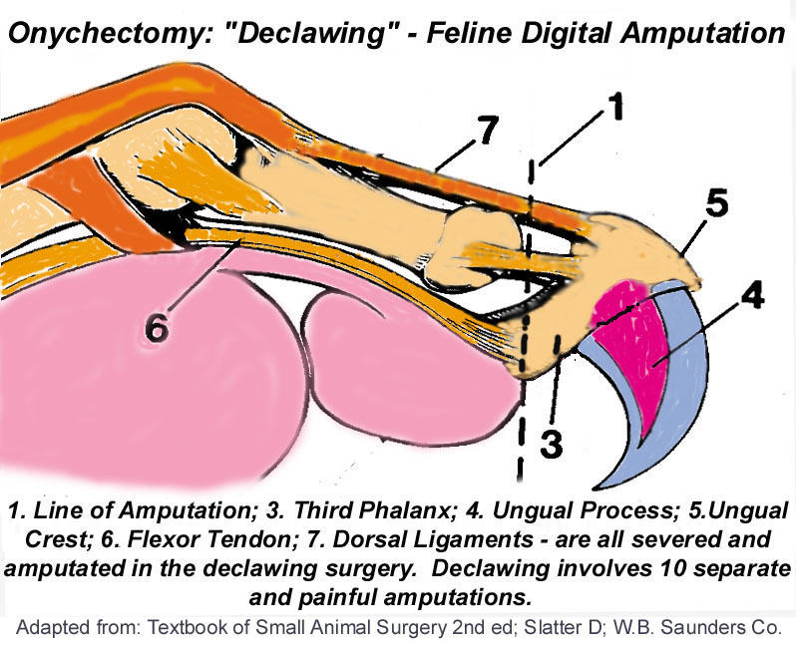
The Cat’s Claws
Unlike most mammals who walk on the soles of the paws or feet, cats are digitigrade, which means they walk on their toes. Their back, shoulder, paw and leg joints, muscles, tendons, ligaments and nerves are naturally designed to support and distribute the cat's weight across its toes as it walks, runs and climbs. A cat's claws are used for balance, for exercising, and for stretching the muscles in their legs, back, shoulders, and paws. They stretch these muscles by digging their claws into a surface and pulling back against their own clawhold - similar to isometric exercising for humans. This is the only way a cat can exercise, stretch and tone the muscles of its back and shoulders. The toes help the foot meet the ground at a precise angle to keep the leg, shoulder and back muscles and joints in proper alignment. Removal of the last digits of the toes drastically alters the conformation of their feet and causes the feet to meet the ground at an unnatural angle that can cause back pain similar to that in humans caused by wearing improper shoes.
Understanding Declawing (Onychectomy)
The anatomy of the feline claw must be understood before one can appreciate the severity of declawing. The cat's claw is not a nail as is a human fingernail, it is part of the last bone (distal phalanx) in the cat's toe. The cat’s claw arises from the unguicular crest and unguicular process in the distal phalanx of the paw (see above diagram). Most of the germinal cells that produce the claw are situated in the dorsal aspect of the ungual crest. This region must be removed completely, or regrowth of a vestigial claw and abcessation results. The only way to be sure all of the germinal cells are removed is to amputate the entire distal phalanx at the joint.

Contrary to most people's understanding, declawing consists of amputating not just the claws, but the whole phalanx (up to the joint), including bones, ligaments, and tendons! To remove the claw, the bone, nerve, joint capsule, collateral ligaments, and the extensor and flexor tendons must all be amputated. Thus declawing is not a “simple”, single surgery but 10 separate, painful amputations of the third phalanx up to the last joint of each toe. A graphic comparison in human terms would be the cutting off of a person's finger at the last joint of each finger.
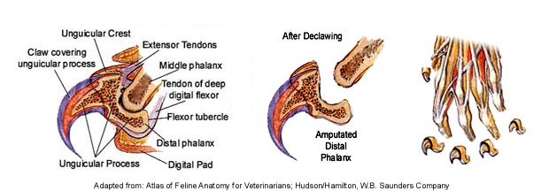
Many vets and clinic staff deliberately misinform and mislead clients into believing that declawing removes only the claws in the hopes that clients are left with the impression that the procedure is a "minor" surgery comparable to spay/neuter procedures and certainly doesn't involve amputation (partial or complete) of the terminal-toe bone, ligaments and tendons. Some vets rationalize the above description by saying that since the claw and the third phalanx (terminal toe bone) are so firmly connected, they simply use the expression "the claw" to make it simpler for clients to "understand". Other vets are somewhat more honest and state that if they used the word "amputation", most clients would not have the surgery performed! Onychectomy in the clinical definition involves either the partial or total amputation of the terminal bone. That is the only method. What differs from vet to vet is the type of cutting tool used (guillotine-type cutter, scalpel or laser).
Onychectomy (Declawing) Surgery
The below is a clinical description of the the declawing surgery taken from a leading veterinary surgical textbbook. Contrary to misleading information, declawing is not a "minor" surgery comparable to spaying and neutering procedures, it is 10, separate, painful amputations of the distal phalanx at the joint (disjointing).
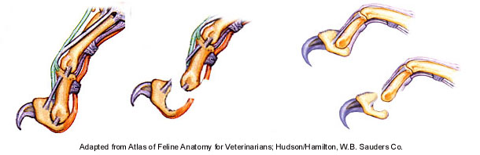
"The claw is extended by pushing up under the footpad or by grasping it with Allis tissue forceps. A scalpel blade is used to
sharply dissect between the second and third phalanx over the top of the ungual crest . The distal interphalangeal joint is
disarticulated (disjointed), and the deep digital flexor tendon is incised (severed). The digital footpad, is not incised. If a nail
trimmer is used, the ring of the instrument is placed in the groove between the second phalanx and the ungual crest. The blade
is positioned just in front of the footpad. The blade is pushed through the soft tissues over the flexor process. With the ring of
the nail trimmer in position behind the ungual crest, the blade is released just slightly so that traction applied to the claw causes
the flexor process to slip out and above the blade. At this point, the flexor tendon can be incised and disarticulation of the joint
(disjointing) completed. Both techniques effectively remove the entire third phalanx." (Excerpted from: Slatter D; Textbook of Small Animal Surgery 2nd ed vol I, p.352 W.B. Saunders Company Philadelphia.)
Complications
Declawing is not without complication. The rate of complication is relatively high compared with other so-called routine procedures. Complications of this amputation can be excruciating pain, damage to the radial nerve, hemorrhage, bone chips that prevent healing, painful regrowth of deformed claw inside of the paw which is not visible to the eye, and chronic back and joint pain as shoulder, leg and back muscles weaken.
Other complications include postoperative hemorrhage, either immediate or following bandage removal is a fairly frequent occurrence, paw ischemia, lameness due to wound infection or footpad laceration, exposure necrosis of the second phalanx, and abscess associated with retention of portions of the third phalanx. Abscess due to regrowth must be treated by surgical removal of the remnant of the third phalanx and wound debridement. During amputation of the distal phalanx, the bone may shatter and cause what is called a sequestrum, which serves as a focus for infection, causing continuous drainage from the toe. This necessitates a second anesthesia and surgery. Abnormal growth of severed nerve ends can also occur, causing long-term, painful sensations in the toes. Infection will occasionally occur when all precautions have been taken.
"Declawing is actually an amputation of the last joint of your cat's "toes". When you envision that, it becomes clear why declawing is not a humane act. It is a painful surgery, with a painful recovery period. And remember that during the time of recuperation from the surgery your cat would still have to use its feet to walk, jump, and scratch in its litter box regardless of the pain it is experiencing."
Christianne Schelling, DVM
"General anesthesia is used for this surgery, which always has a certain degree of risk of disability or death associated with it. Because declawing provides no medical benefits to cats, even slight risk can be considered unacceptable. In addition, the recovery from declawing can be painful and lengthy and may involve postoperative complications such as infections, hemorrhage, and nail regrowth. The latter may subject the cat to additional surgery." The Association of Veterinarians for Animal Rights (AVAR)
Two recent studies published in peer-reviewed veterinary journals (Vet Surg 1994 Jul-Aug;23(4):274-80) concluded “Fifty percent of the cats had one or more complications immediately after surgery.... 19.8% developed complications after release.” Another study (J Am Vet Med Assoc 1998 Aug 1;213(3):370-3) comparing the complications of declawing with Tenectomy concluded “Owners should be aware of the high complication rate for both procedures." Many cats also suffer a loss of balance because they can no longer achieve a secure foothold on their amputated stumps.
Vet Surg 1994 Jul-Aug;23(4):274-80
Feline Onychectomy at a Teaching Institution: A
Retrospective Study of 163 Cases.
Tobias KS
Department of Veterinary Clinical Sciences,
Washington State University, College of Veterinary Medicine,
Pullman 99164-6610.
"One hundred sixty-three cats underwent onychectomy..... Fifty percent of the cats had one or more complications immediately after surgery. Early postoperative complications included pain..., hemorrhage...., lameness...., swelling...., or non-weight-bearing..... Follow-up was available in 121 cats; 19.8% developed complications after release.
Late postoperative complications included infection...., regrowth...., P2 protrusion...., palmagrade
stance...., and prolonged, intermittent lameness....".
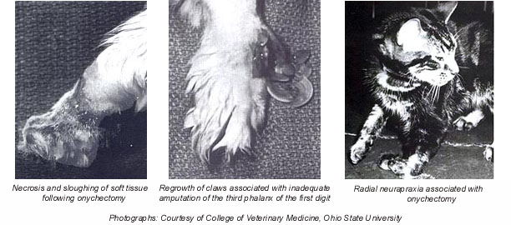
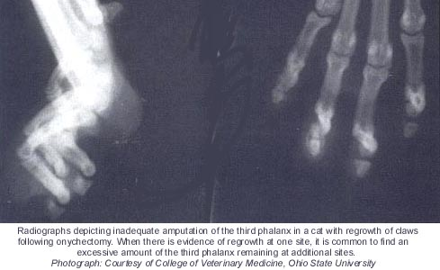
J Am Vet Med Assoc 1998 Aug 1;213(3):370-3
Comparison of Effects of Elective Tenectomy or Onychectomy in Cats.
Jankowski AJ, Brown DC, Duval J, Gregor TP, Strine LE, Ksiazek LM, Ott AH
Department of Clinical Studies, Veterinary Teaching Hospital,
School of Veterinary Medicine, University of Pennsylvania,
Philadelphia 19104, USA.
"Objective: To compare short- and long-term complications after Tenectomy of the deep digital flexor tendons or onychectomy.
Animals: 20 cats undergoing Tenectomy and 18 cats undergoing onychectomy.
Procedure: Cats undergoingTenectomy or onychectomy were monitored for a minimum of 5 months to enable comparison of type and frequency of complications.Type and frequency of complications did not differ between procedures.
Clinical Implications: Owners should be aware of the high complication rate for both procedures."
Psychological & Behavioral Complications
Some cats are so shocked by declawing that their personalities change. Cats who were lively and friendly have become withdrawn and introverted after being declawed. Others, deprived of their primary means of defense, become nervous, fearful, and/or aggressive, often resorting to their only remaining means of defense, their teeth. In some cases, when declawed cats use the litterbox after surgery, their feet are so tender they associate their new pain with the box...permanently, resulting in a life-long adversion to using the litter box. Other declawed cats that can no longer mark with their claws, they mark with urine instead resulting in inappropriate elimination problems, which in many cases, results in relinquishment of the cats to shelters and ultimately euthanasia. Many of the cats surrendered to shelters are surrendered because of behavioral problems which developed after the cats were declawed.
Risk factors for relinquishment of cats to an animal shelter:
- "Among 218 cats relinquished to a shelter, more (52.4%) declawed cats than non-declawed cats (29.1%) were reported by owners to have inappropriate elimination problems."
Source: World Small Animal Veterinary Association - 2001
The incidence of behavior problems following onychectomy in cats; two months to five years (median 11.5 months) after surgery:
- "(33%) developed at least one behavior problem.
- "(17.9%) had an increase in biting habits or intensity."
- "(15.4%) would not use the litter box"
Source: World Small Animal Veterinary Association - 2001
Many declawed cats become so traumatized by this painful mutilation that they end up spending their maladjusted lives perched on top of doors and refrigerators, out of reach of real and imaginary predators against whom they no longer have any adequate defense.
A cat relies on its claws as its primary means of defense. Removing the claws makes a cat feel defenseless. The constant state of stress caused by a feeling of defenselessness may make some declawed cats more prone to disease. Stress leads to a myriad of physical and psychological disorders including supression of the immune system, cystitis and irritable bowel syndrome (IBS)..
"The consequences of declawing are often pathetic. Changes in behavior can occur. A declawed cat frequently resorts to biting when confronted with even minor threats. Biting becomes an overcompensation for the insecurity of having no claws. Bungled surgery can result in the regrowth of deformed claws or in an infection leading to gangrene. Balance is affected by the inability to grasp with their claws. Chronic physical ailments such as cystitis or skin disorders can be manifestations of a declawed cat's frustration and stress" David E. Hammett, DVM
Moral, Ethical and Humane Considerations
The veterinary justification for declawing is that the owner may otherwise dispose of the cat, perhaps cruelly. It is ethically inappropriate, in the long term, for veterinarians to submit to this form of moral blackmail from their clients.
"The Association of Veterinarians for Animal Rights is opposed to cosmetic surgeries and to those performed to correct 'vices.' Declawing generally is unacceptable because the suffering and disfigurement it causes is not offset by any benefits to the cat. Declawing is done strictly to provide convenience for people. The Association of Veterinarians for Animal Rights (AVAR)
Some veterinarians have argued that some people would have their cats killed if declawing was not an option. We should not, however, allow ourselves to taken 'emotional hostage' like this. If a person really would kill her or his cat in this case, it is reasonable to question the suitability of that person as a feline guardian, especially when there are millions of non-declawed cats living in harmony with people."
Most people are vehemently opposed to declawing due to a combination of reasons: 1) because the end (owner convenience) doesn't justify the means (causing unnecessary pain to the cat); 2) because other, less harmful alternatives to declawing exist and 3) because claws are part of the nature or "catness" of cats. Overall, the view is that it is ethically inappropriate to remove parts of an animal's anatomy, thereby causing the animal pain, merely to fit the owner's lifestyle, aesthetics, or convenience without any benefit to the cat. It should be emphasized that "most people" includes virtually the entire adult population of Europe and many other countries around the world.
Many countries are particularly concerned about animal welfare and have banned declawing as abusive and causing unnecessary pain and suffering with no benefit to the cat.. One highly regarded veterinary textbook by Turner and Bateson on the biology of cat behavior concludes a short section on scratching behavior with the following statement: "The operative
removal of the claws, as is sometimes practiced to protect furniture and curtains, is an act of abuse and should be forbidden by law in all, not just a few countries."

A PRACTICAL APPROACH TO FELINE HOUSESOILING

by Susan Little DVM
Diplomate ABVP (Feline Practice)

The most common behavioural complaint about cats presented to animal behaviour consultants in North America is house-soiling. The typical presentation is that of a cat that both uses its litterbox and eliminates outside of it. It is also typical for the cat to deposit only urine or stool outside the box, but not usually both.
It is critically important to discriminate between medical and non-medical causes of a behaviour problem. The common occurrence of feline lower urinary tract disease (FLUTD - formerly called FUS) makes this especially important for house-soiling problems in cats. This holds true whether the problem is soiling with urine and/or stools, or if it involves spraying or marking behaviours. A good history of the problem is second in importance only to the tests required to rule-out medical problems for both diagnosis and treatment. It is essential to establish an accurate diagnosis for each case.
Remember that a problem behaviour is not necessarily an abnormal one - most problem behaviours are actually normal ones which are exhibited in an inappropriate manner.
When your veterinarian is taking a history of a housesoiling problem be prepared to answer questions such as: - detailed description of the problem, its duration, progression and severity - a description of any associated events - a description of any corrections already attempted - a description of the environment: ie. number of animals, number of litterboxes, locations of boxes, interactions between animals, etc. - medical history (ie any history of intestinal problems or FLUTD)
There are 3 basic categories of housesoiling problems:
- normal elimination at an inappropriate site (most common type)
- marking behaviour (spraying). It is important to distinguish between urinating outside the box and spraying - this is done by a description of the cat's body posture and location of the urine voiding.
- medical disease
** or a combination of any of the above **
After taking a complete history of the problem, your veterinarian will want to run some medical tests. A urinalysis is always indicated when house-soiling involves urine, and is usually necessary if stools are involved as well. It is not unusual for a cat to have a medical problem when the behaviour history is suggestive of only behavioural factors. Other tests may involve blood samples to determine if another medical problem, such as kidney disease, is contributing to the housesoiling.
A diagnosis is reached by applying criteria to show which of the potential contributing factors (both medical and psychological) are involved. A working diagnosis has the advantage of suggesting the factors which must be modified in the treatment plan. A treatment plan is then formulated. The plan should be designed to: entice the cat back to the litterbox using any changes (sometimes extraordinary) necessary, and modify the inappropriate site to make it unattractive or inaccessible.
It helps to understand that elimination in cats is actually a sequence of individual behaviours, and a problem can develop at any of the steps involved. In nature, cats have an infinite variety of sites and substrates for elimination, but in a home setting, they are expected to use a restricted number of sites (often only one) and a restricted type of substrate (again, often only one).
The elimination sequence:
- search/approach location - involves visceral sensation
- dig - involves tactile sensation (very important)
- eliminate - involves visceral sensation
- sweep/cover movement - involves tactile sensation
The contributing factors to housesoiling:

- Litter aversion: a common cause of house-soiling. A cat selects a site initially based upon the tactile sensation created when it scratches at the surface. A cat may dislike litter because of:
  - inadequate cleaning (some cats are extremely fastidious, and this can set off a litter aversion)
  - learned aversive association with the litter due to: pain (ie FLUTD), diarrhea, fear (owner catches it in litter to give it medication, or another cat in the house always traps it there to attack it), odour (either from inadequate cleaning, or from deodorizers or cleansers used by the owner)
  - an unlearned spontaneous individual aversion - just doesn't like the tactile sensation of the litter type
  - a plastic type litterbox liner is being used, so the cat catches its claws on it when it tries to dig
  - the litter type itself may be OK, but there may be too little in the box or too much
  - and just to complicate things, some cats dislike the litter if you keep it too clean Signs of litter aversion:
  - cat avoids litter completely
  - cat uses litter, but scratches at the sides of the box, on the floor, or other objects nearby instead of in the litter
  - cat uses litter, but shakes paws a lot during and after using it - cat does not dig in litter
  - cat straddles the box, putting feet up on edge of box to avoid touching the litter
  - cat uses litter, then bolts out of box quickly
  - cat meows at or talks to litterbox
  - cat starts urinating in box in normal squatting position, but ends up standing and spraying urine
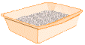
There are several steps that can be taken to correct the problem, but first ensure that the litter is clean. Then be sure you are not using a deodorized litter - some cats find these scents very distasteful and review your cleansing procedure. A product with an odour used in the cleaning process may cause a lingering smell - change your routine, if not in a cattery, try using only very very hot water and no cleanser. If you are using a litterbox liner, stop. Try different types of litter: you may have to try quite a few systematically (for 7 to 10 days each) to find the right one (you may have to try a wide variety of different materials). Cats can spontaneously decide that a litter they have happily been using for years is no longer attractive to them. If you want to make changes to the litterbox filler or location, always make these changes gradually. For instance, if you decide for whatever reason you want to use a new litter, first use an additional box with the new litter and gradually take away the old litter once the cat is happily using the new one. For changing the location of litterboxes, the same applies - add a new litterbox in the new location, and gradually move the old box day by day to the new location (means you will have a litterbox in unwanted places but it's only temporary).
Finally, remember that some cats prefer two locations for elimination: one for urine and one for stool. Providing enough litterboxes for this may be all that's needed.
- Surface preference: a cat may find another surface in the house it prefers to the litter provided in the litterbox. This is very common. Even in cases in which some other factor was the initial cause, a cat can develop a new surface preference. The most common preferred surface is some type of fabric, with carpeting being number one. Sometimes these surface preferences can develop accidentally, ie. the cat accidentally scratched at the bathmat hanging next to the litterbox and develops an association between elimination and the fabric. Cats can also have a primary preference for one type of surface over another - ie they just like carpet better. A nice study involving an experimental trial of different litters for cats (Dr. P. Borchelt, Vet Clin of N.A., 21(2), 1991) showed conclusively that cats prefer finely-grained textures. Therefore, the most preferred litters are the sandy, clumping types. Second most preferred would be actual playbox sand. Third would be the finer traditional clay litters. Last would be products such as wood shavings and recycled newspaper.

There are some cats who actually prefer a smooth surface - they will be the ones eliminating on a floor surface, in the sink, bathtub, etc. They may respond to an empty litter box, or one with a bit of tornup newspaper. You can then try adding litter very slowly and in small amounts to the box. Carpeting presents a particular problem as it is almost impossible to clean. Urine odour is very pervasive and usually soaks into not only the carpet, but the underlay, and even the flooring underneath. For lightly soiled areas, clean with a odour eliminator such as KOE or Outright, or get a professional carpet cleaner in (most home steam cleaners won't help). In many cases, the carpeting must be ripped out or the area re-floored in another material. It may be necessary to place a piece of scrap carpet in the litterbox itself to get the cat back to the box or to build a small platform surrounding the litter that is carpeted, so the cat can perch on the platform.
It may be necessary to block access to areas previously soiled (ie. keep bedroom door closed, cover the soil in plant pots with a fitted mesh or add lots of pebbles, move a large object on top of a soiled area). Areas can be made undesirable by many tactics: covering the area with tinfoil (don't use plastic, many cats love to urinate on it), using moth ball flakes (as long as there is no danger of a child or dog ingesting it and you only need a small amount). For cats who get up on countertops and urinate in things, place a strip of double-sided sticky tape on the edge of the counter so the cat's feet will touch it when he lands there - most dislike the sticky sensation. In some cases, you may need to resort to using a motion detector that emits a noise when the cat disturbs the area, this works very well; and most cats will learn to avoid the area after only 1 or 2 tries. However, be sure you want the cat to totally avoid the area (ie its not your favourite place to sit and cuddle), and if you have neighbours, you better warn them of the noise as it may scare more than the cat. For bathtubs and sinks, leave 1 inch of water in them. For only one or two favouritely soiled areas, try feeding the cat at that spot. In North America, there are companies who sell indoor versions of the "invisible fencing" systems used outdoors that could be used to keep a cat from certain indoor areas.
There are many other creative ways to make a spot aversive to your cat, but they must be used in conjunction with tactics to get him back to the litterbox, for if you train him to avoid one area he will go to another instead. In some cases, it may help to isolate the cat in a small area (typically bathrooms are used) with the litterbox, a sleeping spot, toys, food etc to enforce re-training. Make sure the food is not too close to the litter. This process may have to be carried out for 2 weeks or more. The cat can be allowed out of isolation only when the owner is around to carry it at first, then gradually for little play sessions, or cuddle sessions, gradually increasing in time providing no relapse to house-soiling occurs (if it does, you went too fast, start all over).
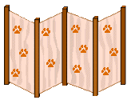
- Location/Litterpan aversion: the location or the box itself can become associated with aversive events for the same reasons that the litter itself can (ie pain, fear, odour, etc.). Most cats prefer an easily accessible spot, but one with some privacy. So strike a balance between getting it out of the way for your own sake, and making it private but not too distant for the cat's sake. Some cats prefer open boxes, some prefer the privacy of closed boxes, most like large boxes, a few like small ones.
Cats will learn a preference in which elimination becomes associated with a specific location(s). This type of preference can develop very quickly if a cat first chooses to go out of the litterbox for any other reason. It is to be strongly suspected if a cat repeatedly goes back to one area, or one room. Some of these location preferences can become ridiculous, so don't be surprised by anything (the most outrageous I've heard is a location preference for the middle of the dining room table). To help treat this type of problem, you may actually have to provide a litterbox in the cat's preferred spot to get the cat using the box again, and then slowly move the box back to another location. Cats will usually dislike having to eliminate where they must eat, so don't put the food bowl and the litterbox side by side.
- Anxiety-related causes: you must always consider the possibility that stress or anxiety is contributing to the house-soiling (still, this is not as frequent a cause of house-soiling as most people think). Types of stress:
  - separation anxiety: previously recognized only in dogs, now believed to occur in cats. Usually occurs when there has been a prolonged absence of an owner, ie over 8 hrs. The house-soiling will occur 8-12 hours after the owner's departure, which is totally opposite to dogs, where the behaviour occurs right after departure. The behaviour may involve diarrhea and destructive events in addition to house-soiling. It can be treated similarly to the way dogs are treated (ie training thru graduated departures - requires a lot of patience and time) and with some medications.
  - fear: cats that are naturally shy or fearful may not want to *come out into the open* to go to the litterbox. In some cases, there is an identifiable fearful stimulus, ie a certain person, cat, dog, object, sound that can be modified or removed. Desensitization and counterconditioning methods can also be used. You may have to provide a litterbox for that cat in some *safe* location.
  - overcrowding: there is a large variation in individual tolerances for overcrowding. Where some cats may be happy with 20 other cats in the house, others will dislike even 1 other cat, or even one other animal of any kind. Cats do not naturally live in social groups all the time, they spend much of their lives in solitary circumstances and get together for breeding or they may raise kittens communally, or if they are forced to by a limited food supply. Many cats may view all living beings (including people) in the home as part of the social group, and adding to the group in any way can upset them. You can decrease the number of cats/animals, you can increase the amount of vertical space available by adding cat trees, or even clearing bookshelves to allow cats to perch there (be creative). You can separate the cats/animals into smaller colonies within the home either on a permanent basis, or for a few weeks to resolve the problem and then try re-introducing.
In summary, make the simplest changes first, make all changes gradually, be prepared to address multiple factors, and be prepared to modify your treatment plan.
The prognosis is variable, and it partly depends on getting an accurate diagnosis. The longer the problem has been going on and the more severe the problem and the more animals in the home, the graver the prognosis.
For new kitten owners there are steps to take from the start to try to avoid housesoiling problems:
- make the litterbox location easily accessible, but in a low traffic area
- - try to provide 1 litterbox per cat (or for those cats that prefer 2 locations, two boxes for the one cat)
- use finely-grained litter types
- do not put food and water beside the litterbox
- scoop the box at least daily, change traditional litters at least once weekly and scoopable litters every 6-8 wks
- avoid frightening the cat in the litterpan, or trapping and catching it there
- **never, ever, ever punish a cat for house-soiling
- **make any changes to the litterbox filler or location gradually
- ** call the vet quickly if any housesoiling occurs
WHY CLAWS ARE IMPORTANT TO CATS
The feline is one of the most graceful, well-designed creatures on this Earth. A cat spends about one third of its time when it is awake grooming itself. The claws are a very important part of this function, and used extensively to help keep the cat's fur smooth and clean. This is not just for "good looks" -- grooming is the way a cat controls body temperature and the affects of outside temperatures; grooming also controls the scent signals used by the feline body; grooming is important for cleanliness, health, and for waterproofing the cat's body. The licking and scratching that a cat does while grooming itself or in social grooming combs out tangles in the fur, and removes skin irritations and dead skin and hair. There is no way a cat can use its teeth effectively to reach the important areas of the neck, head and mouth for grooming, and teeth are not nearly as efficient in keeping the other parts of the body in perfect condition.
Claws also help the feline to climb, which is part of the instinctive nature in almost all cats. While some cats can learn to climb without their claws, they will never experience the same joy and confidence in that exercise without the exactness and pinpoint contact of the tips of their claws on climbing surfaces. The act of scratching itself is often a form of greeting by felines, and provides a source of psychological comfort through its rhythmic action. In addition, scratching is a source of reassurance to the cat of its ability to defend itself or to choose not to defend itself, which can be witnessed by watching the cat contract its claws and "knead" its owner with contentment and trust.
Without claws, a cat will not be able to defend itself, nor will it be able to hunt. Without claws, should a cat ever get out from the safety of its home, or the owner suddenly be unable to take care of the cat for whatever reason, the cat will no doubt perish from starvation, as it will no longer be able to take care of itself and provide itself with food.
POSSIBLE CONSEQUENCES OF DECLAWING
Changes in behavior are not uncommon in declawed cats. Some declawed cats will resort to biting behavior when confronted with even very minor perceived stress or threats. This behavior is the overcompensation for the cat's insecurity about not having any claws. Sometimes, a cat's sense of balance is affected by not being able to grasp and measure objects with their claws. Chronic physical problems such as cystitis and skin disorders can all be the results of a declawed cat's sense of frustration and high degree of stress. Remember, too, that it IS possible for serious infections to occur, and for the claws to even grow back, often in a deformed and difficult-to-treat state.
ALTERNATIVES TO DECLAW SURGERY
You do not have to share your home with a kitty who continuously scratches and destroys your home, furnishings and belongings. Most felines can be trained quite easily to use a tall, sturdy and heavy piece of cat furniture for their scratching needs. Placement of this furniture is critical, and best success is achieved by understanding why the cat scratches in the first place, and making sure the cat furniture is placed correctly to meet those needs.
We have found that by using leather, vinyl or combination leather/vinyl furnishings in our main living areas, our cats have little or no desire at all to scratch our furniture. The type of fabric to avoid is the loosely woven fabrics for living room couches and chairs, as cats love to get their claws under the fabric loops.
It may seem rather simplistic, but taking the time to TRAIN your kitty is also usually quite effective - whether you use "NO" in a firm warning voice, followed by a squirt from a water mister, or whether you choose to discourage his undesirable scratching behavior by leaving the room. BE PATIENT...and BE CONSISTENT.
Keep the front claws neatly trimmed, being careful not to cut in to the "quick" area where the blood flows to the nail. If you have any doubts, have your vet show you how to trim your kitty's nails properly.
There are products out now such as SOFTPAWS©, that can be used (sort of like Lee Press-on nails) to discourage a chronic furniture scratcher. Take the time to try these products before even considering the permanent, irreversible, expensive and mutilating declaw surgery, as they have worked for millions of happy cats and their owners.
Until your cat learns that his scratching needs to be on his post (or posts - you can never have too many, and it's best to have at least one in each room where your cat spends significant time), you may want to try covering his favorite human furniture with double-sided sticky tape, a separate throw, blown up balloons taped to the furniture, aluminum foil, or some similar distraction.
When you have the opportunity, remember to NEVER use your hands and arms in play with your kitten or cat. Responsible breeders start working with their kittens at a very young age, teaching them the difference between toys (meant for play) and human body parts (meant for giving and receiving love). This all plays a big role in the proper development of cat behaviors such as appropriate ways to handle teething, and not turning in to cats that bite or scratch people and/or furniture. With the development of proper cat behaviors such as these, there never becomes a need to even consider the idea of declawing.

